

2018

Development of a Mobile Game

HOT TOPIC IN SOFTWARE 502.714

Table of Contents

**List of Tables** 3

**Image Used** 3

**Executive Summary** 4

**Chapter 1: Initiation** 5

**2.1 Introduction** 6

**2.2 Stakeholders** 6

**2.2.1 Internal Stakeholders** 6

**2.2.2 External Stakeholders** 6

**2.2.3 Stakeholder Analysis** 7

**2.3 Inside the scope** 7

**2.4 Out of Scope** 7

**2.5 Project Timeline** 8

**2.5.1 Research** 9

**2.5.2 Planning** 9

**2.5.3 Design** 9

**2.5.4 Implementation** 9

**2.6.5 Evaluation** 9

**Chapter 3: Requirements** 10

**3.1 Introduction** 10

**3.1.1 Software Requirements** 10

**3.1.2 Design Creativity** 10

**3.1.3 Research Results** 10

**3.1.4 Software Skills** 10

**Chapter 4: Literature Review** 11

**4.1 Introduction** 11

**4.2 Common ‘Food Falling’ and ‘Healthy Eating Awareness’ games.** 11

**4.2.1 Blamburger – Clarence** 11

**4.2.2 Catch the Carrot** 11

**4.2.3 Falling Food** 11

**4.2.4 Falling Food (2)** 12

**4.2.5 Healthy Hero Pro** 12

**4.2.6 Summary** 12

**Chapter 5: Risk Management** 13

**5.1 Introduction** 13

**5.2 Main points** 13

**5.3 The Risks** 14

**Chapter 9: Conclusion** 18

**References** 19

Bibliography 19

# **List of Tables**

1. Table 1: Internal Stakeholders with Details 7
2. Table 2: Stakeholder Analysis 7
3. Table 3: Out of Scope Description 9
4. Table 4: Healthy Food Mobile Game Comparison 13

## **Image Used**

1. Image 1: Gantt Chart detailing our plan 11

# **Executive Summary**

This report is created to analyse, provide reason and the ideology behind creating our project. The requirements are to create a project that is relevant towards a particular hot topic in the IT industry today. We will begin by describing the initial creation process of our project to explain the understanding behind why we made certain decisions regarding the projects creation. From there we will then move onto on our planning phase. This will mostly consist of who will be involved with our project and breakdown how we intend on making the project. Detailed in this chapter will be our SDLC model broken down to give an understanding of the estimates we have made towards how long our project will take to create. The next chapter will include detailed specifics about certain individual skills that will be required for our plan to stay on track. Chapter 4 will include our literature review which is our way of comparing current implement software and sharing the ideas behind why we think our project is different and justify its feasibility and creation. Finally, we will be talking about how we will be maintaining potential hazards towards the creation of our project, and our ideas behind risk management and how to prevent them. The last paragraph will refer to a conclusion of the report our ending outcome.

# **Chapter 1: Initiation**

The report at hand includes creating a project which can identify with a chosen hot topic in the IT industry.

The topic we have chosen to create our project, is development of a mobile application. Mobile applications are commonly known as apps (Mobile app, n.d.). In the modern-era today, mobile apps are among the most common used software as with the influx in popularity of Mobile phones more people are accessible to mobile applications. Mobile app development was also a big interest from our team as it is a potential career pathway we look at pursuing in the future. With mobile applications we have decided to base our application around a game. Currently the popularity of mobile games grows everyday due to the accessibility mentioned above. The reason we chose a game is because we wanted to create something that is interact and fun to use. This is important because games allow a broad range of users to play them due to their ease of access.

After choosing our topic we were than tasked with what our application should include. After Research and further discussion with Fadi, we decided to base our application around ideas that could potential lead to the reduction of social economy issues that our homeland (New Zealand) currently faces. We came across a high statistic rating with obesity in New Zealand as of 2017 New Zealand ranked as the third most obese nation according to an article posted in News Hub (Obesity in NZ, 2017). This is a glaring issue as 30.7 percent of adults in New Zealand classified in the obese category which is an increase from the 2007 rating 26.5 percent. This tells us that in the past 10 Years the issue has not only gotten worse but that it is slowly rising, and we could be looking at a potential increase soon.

These are the main factors that contribute to the obesity statistic, lifestyle choices, medical conditions, and genetics. The main one being lifestyle choices, as you have minimal control over things you are born with. Lifestyle choices or otherwise maintaining a healthy lifestyle narrow down to two important components, Eating and Exercise. Eating and Exercise are very important in the average life of a human as it’s what our body needs to function at an optimal rate. Research in maintaining a healthy lifestyle indicates that by ratio, 70 percent of it includes eating and the other 30% is from exercise. This tells us that not only is Eating or maintaining a healthy diet vital to your health but that if you don’t have time to get to your local gym, with a correct diet your body should function at an optimal rate.

Scope refers to the content of our project and what research is required. The scope of our research will involve raising awareness around maintaining a healthy diet via a mobile game. We have chosen a healthy food lifestyle and mobile app development to keep our scope as narrow as possible to increase our chances of finishing our project within the allotted time frame. This will also be beneficial as currently there are no such applications that are attracting to users and educate them about nutritional information.

The aim of our project is basically what we want to achieve by creating our application. While the content we will base our application around has been identified. We wanted to be more specific and break it down into one main goal. This is represented by our aim which as a basic statement can be read as follows.   
“We are hoping it will have an impact on society by raising awareness that unhealthy foods can be detrimental to your health and thus reducing the obesity statistic “.

With our aim fully realised, we then worked out how we were going to achieve our aim. Below we have included the main objectives that will be milestones we follow during each stage of our project. It is important that we accomplish each object as not only will it be telling us we are staying on track but also that we don’t lose sight of the initial aim of our project. These will also be explained further in the project schedule section of the report

The objectives are:

1. Researching healthy food alternatives/
2. Researching skills to make the software
3. Planning using Project Management software
4. Prototype Design
5. Prototype Model
6. Compile Model
7. Software Evaluation
8. Document everything

**Chapter 2: Project plan**

## **2.1 Introduction**

Project plan is the who and how of our project. With our topic and aims fully realised, the next tasks were to figure out how we were going to make it all possible. The report will document each stakeholder involved in the project and why they are key towards the outcome of the project. Detailed in this chapter will also be the timeline and tasks included in our project based of our chosen methodology which is Agile.

## **2.2 Stakeholders**

The stakeholders are people that are involved or have an interest in this project. There are internal and external stakeholders.

### **2.2.1 Internal Stakeholders**

The internal stakeholders are those considered to be directly involved this project (internally). See Table 2.1 for the list of internal stakeholders.

**Table 1:** Internal Stakeholders with Details

|  |  |  |
| --- | --- | --- |
| Name | Role | Contact Details |
|  | Project Leader | main82@manukaumail.com |
|  | Head Developer |  |
| Fadi Fayez | Client |  |

### **2.2.2 External Stakeholders**

The external stakeholders are those are not directly in this project but are affected or care about its result. The external stakeholders for this project are as following:

* Fadi Fayez (Lecturer)
* The users of the mobile application – Children & Teenagers

### **2.2.3 Stakeholder Analysis**

The table below demonstrates the stakeholder analysis. This is created to show how each stakeholder has an impact on this project to alter the results and goals.

**Table 2:** Stakeholder Analysis

|  |  |  |  |
| --- | --- | --- | --- |
| Stakeholder | Influence | Objective | Strategy |
| Project Leader | High | Ensures delivery of the project within the timeframe. Responsible for conducting meetings with Head Developer and Client. | Complete Project within time frame. Organise meetings. |
| Head Developer | High | Communicate with Project Leader. Responsible for contributing to project and development plan. | Meeting with Project leader and client. Create software development plan. |
| Client | High | Express to team feedback and ideas. Responsible for ongoing support during project | Meeting with Project Leader and Head Developer |
| Users | Medium | Express feedback when shown the prototype. Responsible for playing the game | Meet with Team to test the prototype. |

## **2.3 Inside the Scope**

The objective of the project is to create a mobile application that will raise awareness about healthy eating via mobile game. This will prove very important towards combating the growing statistic in New Zealand that is obesity

## **2.4 Out of Scope**

Listed below are things that will be considered as measurables outside of our scope

* Application Quality
* Application Delivery
* Meeting deadlines
* User Interaction
* User Response

**Table 3:** Out of Scope Description

|  |  |
| --- | --- |
| **Measurables** | **Why is this important** |
| Application Quality | Application quality refers to how well we rate the overall performance of our game. If all the functions operate as intended, how well the design turned out. For our game we will judge the design of our UI and ensure the game operates as we want it too. |
| Application Delivery | Application delivery refers to how well we can source out our application. Making it available for download on our platform of choice. This is important as it gives us an idea on how much people we are allowing to download our app. Very important when it comes to risk management also as if we do not source out our application correctly than we risk losing potential audience which affects user interaction and response. |
| Meeting Deadlines | Meeting deadlines details how well we can complete our tasks according to our plan constructed using the agile methodology. Also making sure all the objectives that were identified are completed according to start and end date. If tasks are behind or ahead this will be taken into consideration for how well we are expecting the final quality result of application to be. |
| User Interaction | User interaction refers to how many people are downloading and using our application. This is important as it gives a team a ratio to base our decisions off. |
| User Response | User response is the feedback or reviews that we receive from people that are currently using our application. This will give our team an idea of where we a going wrong in terms of the design of our application. Potentially we will be looking at adding a survey function to our app based on how far we go in our development |

## **2.5 Project Timeline**

The project will work on a timeline that takes 39 days to complete. Since we have selected agile as our methodology we have developed a plan according to agile structure. We have identified 5 key stages of our timeline these are research, planning, design, implementation, and evaluation.

### **2.5.1 Research**

Firstly, before we progress with any coding or creative design we must research. A fair bit of documentation is required as our objectives/scope and opportunities need to be discussed. The skills to make the software need to be researched. After this we propose our idea to the client and gather feedback.

### **2.5.2 Planning**

This is where we can start thinking about the software development and make any necessary charts to help us. We will gather the software needed to invent the game. Technology configuration may be required; for example, the Head Developer will need to install an Android emulator to debug code on his end, as he does not use Android devices. At the end of this phase we will show our progress to the client to acknowledge his feedback.

### **2.5.3 Design**

The design phase is all about creativity. We will be using Photoshop, Paint and our own artistic skills to develop prototype images and designs of what our mobile game will feature. We will also be documenting exactly how the game will work and all its functionalities. Following all this will be more feedback from the client.

### **2.5.4 Implementation**

(Queppelin, 2016) Once the design is ready then it is the time for you to build the App.Agile methodology is the best approach for mobile application development as it allows you to make changes, add new features and keep evolving with the changing trends.

Where all the coding is involved, the implementation is the longest phase in this project. This is where all our research, planning and design is used and evolved into a working game. We have dedicated 3 weeks to accomplish this phase. The way we implement our project will be using Agile methodology. We will seek feedback from the client at the end of this phase.

### **2.6.5 Evaluation**

Finally, the evaluation phase, the last step in the process. The project will be tested now and getting ready for deployment. We endeavour to create a Google Play Store Developer Account and upload the finished project to the Play Store.

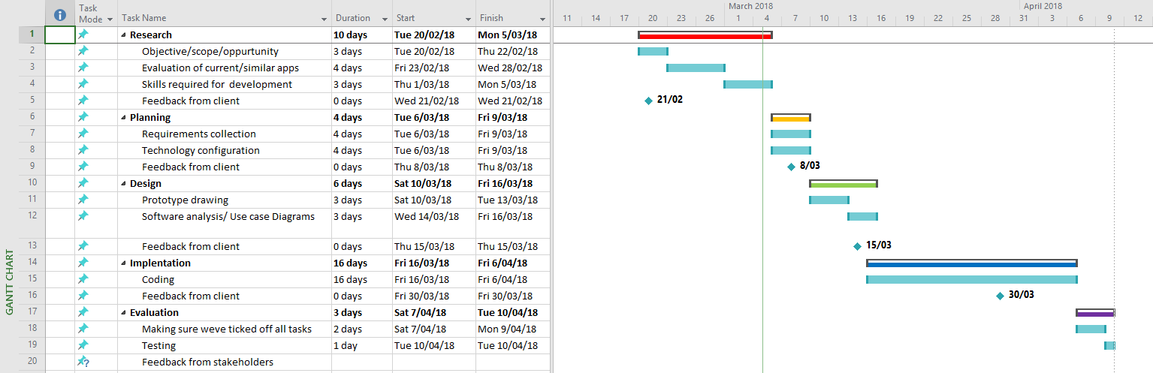 Image 1: Gant Chart detailing our plan

# **Chapter 3: Requirements**

## **3.1 Introduction**

We are going to require several requirements to implement our solution and publish it to the world. These requirements include software, design creativity, research results and the actual software skills to code the game.

### **3.1.1 Software Requirements**

* As discussed together and after some research, we have decided to create our game through the software ‘Unity’. Unity is a coding platform that targets the development of 2D and 3D gaming. With specific android development as an option, and an extension from the Visual Studio platform that we are familiar with, Unity seems like the ideal way to go.
* To develop our own images, characters, items, we are going to use and require the Photoshop software to design and create original entities.

### **3.1.2 Design Creativity**

* To make our game different from all the other games that follow similar functionalities, the project is going to require a large amount of creativity from both team members. We want not only original but also creative and sharp entities on our game. This will make us stand out from the crowd.

### **3.1.3 Research Results**

* Collecting and analysing the results from our targeted research will be critical to ensure that we revolve the game around our focus on raising awareness about healthy eating. We need to know what foods are good for you and what is the most detrimental foods to your health, so our game has meaning and is not a pointless food catching game.

### **3.1.4 Software Skills**

* Game development is a field that both team members are highly interested in, however unfortunately not had much if any experience. We are both 3rd year Degree students with moderate experience in software development, mostly in web development and window-based programs. The game is going to be made using Java and XML languages. The trickiest milestone is going to be synchronising our own made visual pieces (I.E Character, foods falling) to be animated to do what we want.

# **Chapter 4: Literature Review**

## **4.1 Introduction**

The following section will review and highlight some chosen mobile game that have similar characteristics to our idea and objectives. These are a mix of educational and non-educational games but what they all have in common is food falling from the sky and having to catch it one way or another. The strengths are weaknesses of each mobile application will be identified, along with what can be iterated into our implementation. A table at the end of this section will explain a simplified version of the difference of functionalities and other differences from our analysis.

## **4.2 Common ‘Food Falling’ and ‘Healthy Eating Awareness’ games.**

### **4.2.1 Blamburger – Clarence**

Blamburger is a mobile game that was developed in Georgia USA, by the company ‘Cartoon Network’. This is a popular game with 1,000,000 plus downloads, as it is based from a Cartoon Network kids television show: Clarence. This game consists of the character Clarence, constructing a sandwich from a variety of sandwich food falling from the sky. The user chooses what ingredients to catch and can finalize the sandwich by catching the top bun. It is a unique game being based off the T.V show and is enjoyable to play. The functionalities include being able to move the character left and right by tapping the direction you want to go. There is a no cap point system, and you can achieve different amounts of points depending on how big you make your sandwich. The weakness of this game is that it is not an educational game, so some of the few negative comments that the app received on the Android Play Store mentions it is a ‘Time wasting game’. The overall score for this game is 4.1/5.

### **4.2.2 Catch the Carrot**

Catch the Carrot was offered by the University of Illinois (USA), and is currently on the Play Store with roughly 1000+ downloads. This is a more educational game that is aimed specifically for the kids to teach them about nutrition and healthy foods. The developers have induced an educational trivia, with a simple slider game. The user firstly receives a question about food and if they answer correctly they then have the game aspect to catch the food into the shopping trolley. The goal is to answer the questions right and catch as many foods in the trolley, then emptying it to receive your points. If you get a question wrong, you cannot move your trolley for that round. This game has a levelling system for the user to work through, getting trickier questions each level. This game has a 3.7 Play Store rating with not much user feedback. The strength of this game is that it is very educational with an enjoyable game included. The weakness is that the game can be a bit slow to play.

### **4.2.3 Falling Food**

Falling Food is a game made by the group ‘OneGuyGames’ from the UK. This is a less known game with about 100 downloads, however it has a strong five-star rating on the Play Store from 6 reviews. This is another game targeted for the younger generation, although due to the smooth game play it can be enjoyed by adults also. While playing the game, there is numerous amounts of foods falling from the sky, and your role is to catch all the foods into the basket you are holding. There are also bombs falling and you need to dodge them to prevent your score from decreasing or the game from ending. There is a sliding functionality where the user only needs to slide the character left or right depending where they want to go. What makes this game strong and unique from the others is that it has two enjoyable game modes, both with a point system. While this is not an educational focused game, it does have a reasonable aspect of healthy eating as most of the foods that are falling are fruits and vegetables. The bombs falling may be a little graphic for the younger ones and that would be its only weakness.

### **4.2.4 Falling Food (2)**

Another mobile game with that shares the same name as the previous app. This was developed in San Mauro Pascoli, Italy. The first thing to notice about this app is that it is not in English. However, with the small amount of text, the game is still very much playable. It has about 10 downloads in the Android Play Store with no reviews. Although this game is not targeted to be educational about healthy eating, it does show a strong message not to waste food. To play the game there is a left/right slider functionality where you control a shopping basket and must catch all the fast falling food from the sky. When you have let a certain amount of food hit the ground the game ends. The goal is to not let the food fall to the ground and get the highest score possible. It seems like an enjoyable time-wasting game, although its main weakness is that you cannot access the game in English.

### **4.2.5 Healthy Hero Pro**

Healthy Hero Pro is a mobile game offered by Ganaysa from unknown location. It has around 100 downloads and has a 4.6/5 Play Store rating. In the game you portray a superman like character who is flying in the sky, with the objective of flying through and catching the healthy foods while avoiding the junk foods. Any time you hit a junk food you lose a life and you have three lives before the game ends. The game has the strong idea of healthy eating awareness and still an enjoyable game. It is also a game that kids can play but also adults. It even has an achievement system, to track your progress and motivate you to keep playing. The only weakness would be the simplicity of the graphics in which can be improved.

### **4.2.6 Summary**

This summary is followed by a table that clearly identifies the key differences between the targeted mobile applications. The common up that the other mobile games had were friendly graphics, which was important for this type of application as it needs to draw kids attention, whilst getting the message of healthy eating to them. A common negative about the reviewed games to be taken into account would be the awareness itself, most of the games were relatively boring and generic and had no sense of awareness of a positive message. We need to ensure to implement this into our game.

Without a doubt the Blamburger game was the most widely known thanks to being related to a popular Cartoon Network show. The graphics of this game also outshined all the rest, as though it seemed like it was professionally made by a large team. Other than that, the functionalities were pretty much the same as the other games. The two main ways developers created the game to play was to either slide the character or tap in the direction you want to go. After playing several games we have come to the realisation that the sliding functionality is a better way to go. If we can combine that sliding function, with an attempt of an exciting graphic user interface and an educational aspect like what the Catch the Carrot game had, this should become a successful mobile game.

**Table 4:** Healthy Food Mobile Game Comparison

|  |  |  |  |  |  |  |  |  |  |  |
| --- | --- | --- | --- | --- | --- | --- | --- | --- | --- | --- |
| App Name | Developer | Target | Rating | Reviews | Apple iTunes | Play Store | Use of Image | Use of Video/Animation | Language | Reference |
| Blamburger | Cartoon Network & Advanced Platforms | Teenagers & Children | 4.1 | 29,749 | √ | √ | X | √ | Arabic, Chinese, English + 8 more | Google Play Store, 2018 |
| Catch the Carrot | University of Illinois | Toddlers & Children | 3.7 | 7 | x | √ | √ | √ | English | Google Play Store, 2018 |
| Falling Food | OneGuyGames | Children 3+ | 5 | 6 |  | √ | X | √ | English | Google Play Store, 2018 |
| Falling Food | Maicol07 | Children | x | X |  | √ | X | √ | Italian | Google Play Store, 2018 |
| Healthy Hero Pro | Ganasya | Children | 4.6 | 5 |  | √ | √ | √ | English | Google Play Store, 2018 |

# **Chapter 5: Risk Management**

## **5.1 Introduction**

This Chapter introduces risk management which is the estimate and calculation of potential hazards that could delay our progress during the creation of our project or cause our project to fail based on the aims/objectives that we had set for our project during the planning phase. Since we are creating a mobile game we will be approaching risk management from the point of view of a mobile game and detailing how we will attempt to resolve each of the problems.

## **5.2 Main points**

* Mobile App development skill- As this will be our teams first time coding a game. Coding skills especially in our chosen language which is Java and XML. To combat this research is required in the specific coding languages to make our sure we are fully equipped with the skills and knowledge to complete the coding section of our project.
* Sourcing of our Application- With all applications a key part in gaining audience attention to download the application is how you outsource it or make it available. To ensure we are sourcing our application at the best rate possible research will be conducted and a plan for the outsource will be created prior the design section of our plan. This way we will be ready to publish our game onto the channel that we deem best at the fastest possible time.
* Updates- A big problem in current modern mobile applications is there are always bugs/glitches that cannot be discovered during the testing phase of the project. This means that our game will require constant maintenance in case of emergency errors being discovered by users. Also, extra time will be allocated towards the testing phase of our project to accommodate for this one risk. Could potentially look at meetings with users (Schools/Kindergartens) to get a different perspective on how they would approach our UI and game design.
* Competitor games- Like with any product A key contributor towards its success is how much it compares to its competitor. With our game we want to minimise this risk as much as possible by creating a game with a different function than those currently available. This was further documented in the Literature review phase of the report.
* Data loss- Potential data loss can happen at any time by a natural cause such as power outage or faulty battery. If any type of data corruption were to occur with our project, it could potentially prevent the production of our project overall.

## **5.3 The Risks**

Table 2.1 List of risks

|  |  |
| --- | --- |
| **Risks** | **How to resolve?** |
| Mobile App development skill | The risk for this can be minimized with efficient skills and knowledge gained by our team. Also taking advantage of our resources such as communication with lectures who specialize in our chosen topic. |
| Sourcing of our Application | Research into popular application channels and how to source correctly. Will follow up into our plan so we are ready to source our app once implementation stage has begun. |
| Updates | We will continue to provide support to our application until we are sure it is at a stage where bugs and glitches are minimal. |
| Competitor games | We will conduct research specifically to look at the flaws and benefits of current application that are similar to calculate what additions we should add to our game design to give them the best possible outcome of success. |
| Data loss | To protect our data from potential failure or corruption we will aim to save it to our online drives accordingly this way we have multiple saves of our data and reduce the risk of data loss. |

**Chapter 6 : Design and Analysis**

**First Design**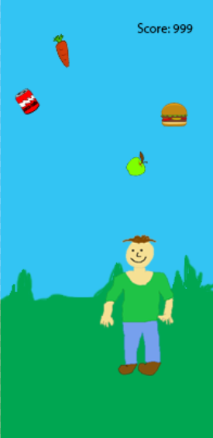

The original intent of our game was to be made through our own animations and imagery. However after discovering that neither of the team members had the ability to carry that idea out, we have decided to get the background, character, and falling foods from free sources on the internet.

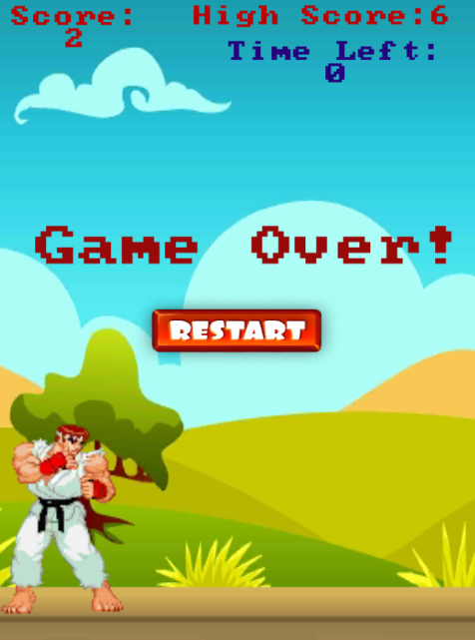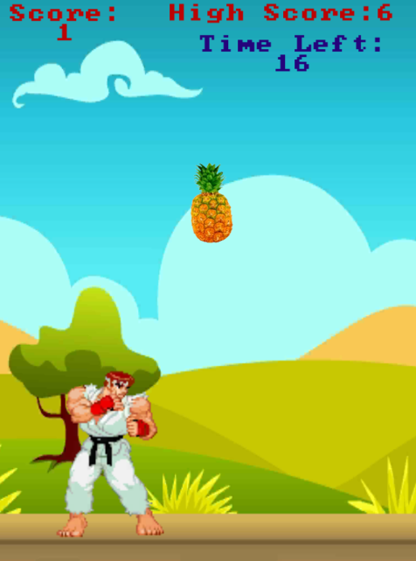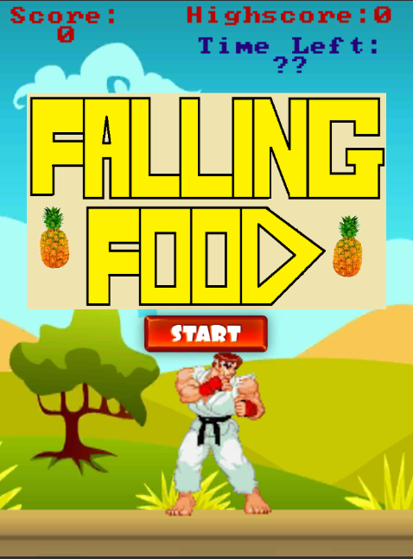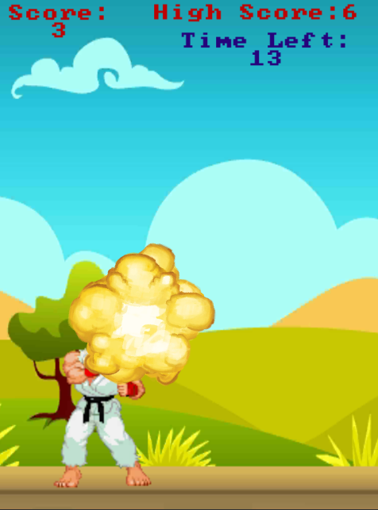**Final Design**

Screen after game ends

Hitting a junk food, which explodes, in game

In game screen

First screen when the game is opened

**Chapter 7: Implementation and Testing**

**Functionalities of the game**

* Splash Screen at the beginning with a start button
* Array of foods spawn from top of screen (Healthy and Unhealthy)
* Character is slide able, with mouse or touchpad
* Timer is shown, expressing how much time in the game remains
* Score counter kept keeping track of your in game score
* High score counter keeps track of your highest obtained score, and saves it even when you exit the game
* Junk foods explode, decrease score by 2 and sound effect occurs when hitting the character
* Healthy foods disappear (get consumed) when they hit the character, and increase the score by 1
* Once Timer is completed than the game ends
* Once game end has happened a message displays on screen which states that the game is over.
* High score is created based on the highest score achieved by the player, high score is also saved until closing of the application
* Restart button than appears on screen prompting user if they wish to play again. If clicked, then goes back to the splash screen.

**Testing**

As we took an Agile approach to our mobile development game, the testing was continuous throughout the implementation phase. After each section of our game was completed, an intensive testing period will occur where we make sure everything is working and proper before continuing to add the next functionality. The Implementation phase took around 4-5 weeks overall as we begun early during the design phase.

**Chapter 8: Results Analysis**

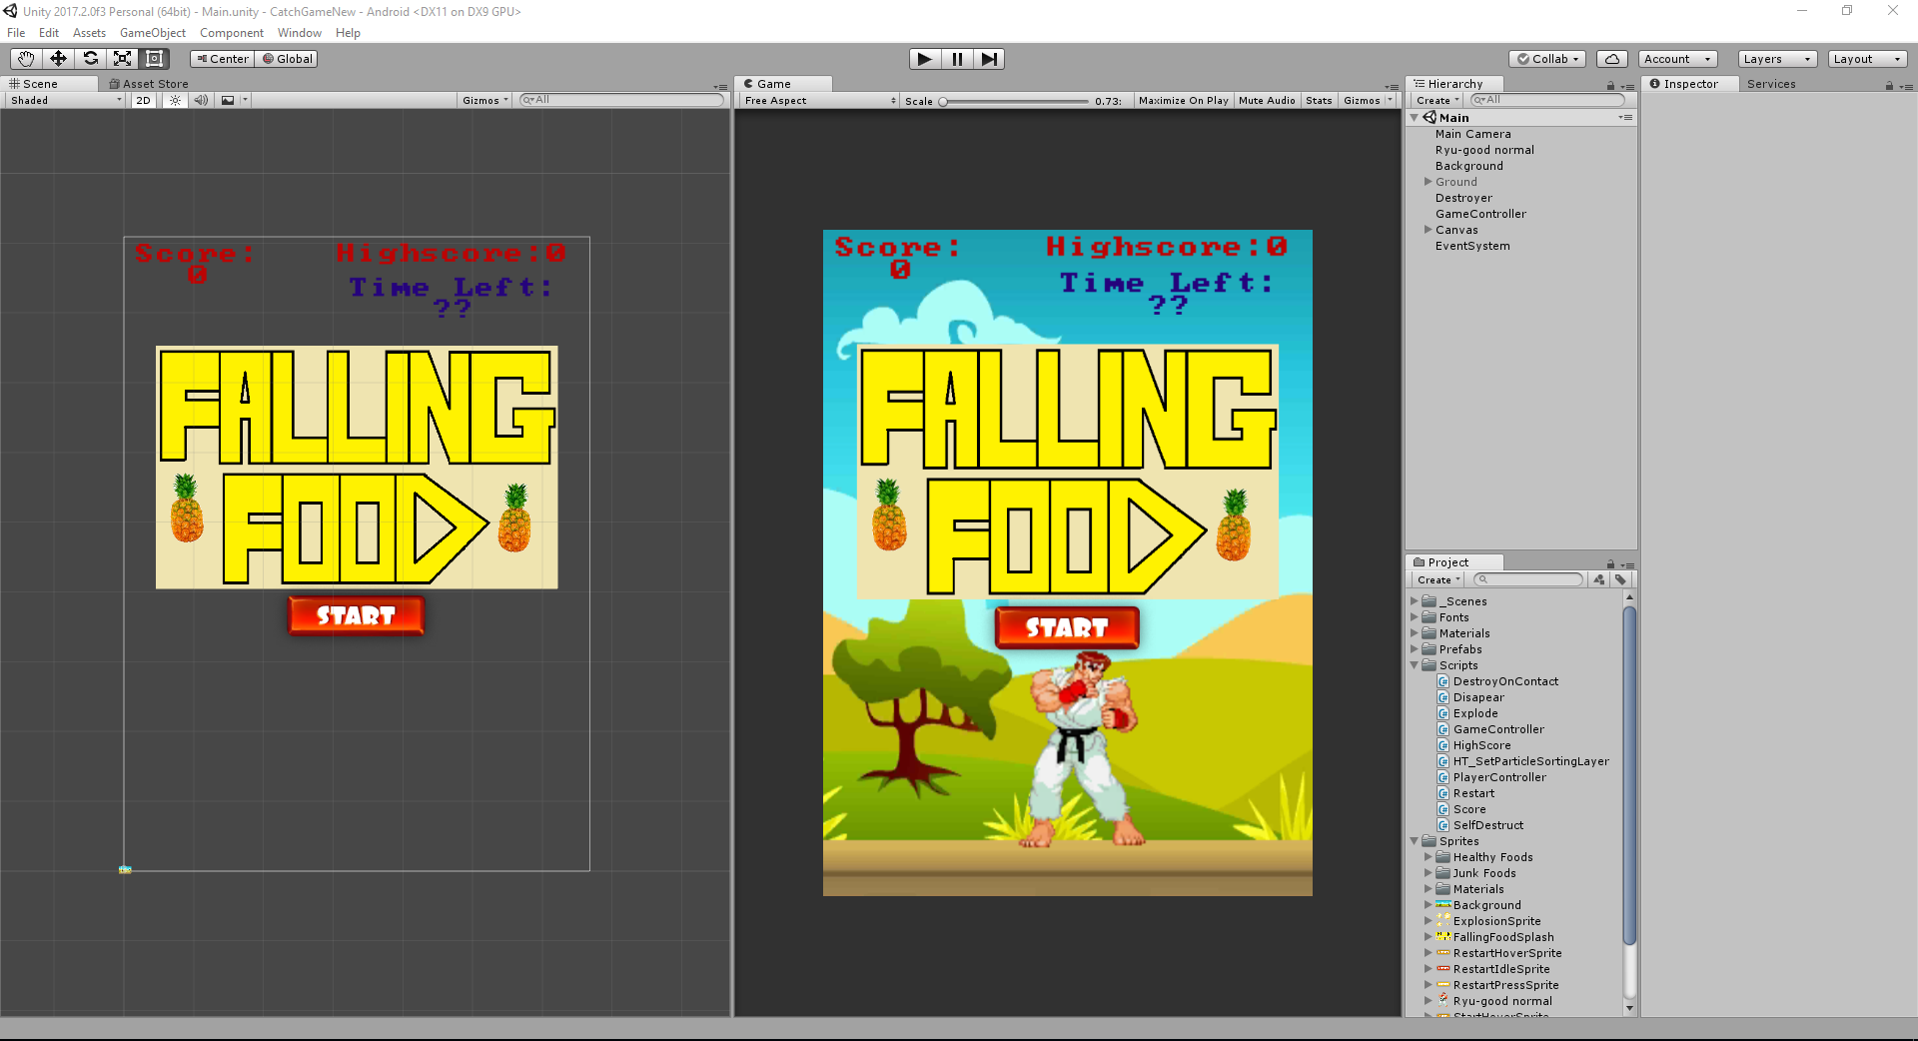

The result of mobile application was a success. Even if we didn’t get all the functionalities working that we wanted, we got the main function of the game working including the awareness aspect of healthy eating. If the extra functionalities were installed in future time and the graphics tidied up a bit, the game could be deployed onto the Google Play Store.

# **Chapter 9: Conclusion**

Everyone has the potential to become a healthier version of themselves, due to the availability of healthy food. Our mobile application endeavours to tackle the problem of obesity. If 10 people play this game and are inspired to eat some fruit, then that will be a success for us. In this report, the process of how we are going to do produce the solution and our motives behind it all are explained. This was written throughout the initiation documenting, project plan (including a Gantt chart), requirements, literature review and risk management chapters. Design, implementation and testing and results analysis are found at the end.

# **References**

# Bibliography

*Mobile app*. (n.d.). Retrieved from Wikipedia: https://en.wikipedia.org/wiki/Mobile_app

*Obestiy in NZ*. (2017, 10). Retrieved from NewsHub: http://www.newshub.co.nz/home/health/2017/10/new-zealand-the-world-s-third-most-obese-nation.html

*8 Phases of Mobile App Development Lifescycle.* (2016, 22 September). Retrived from <http://www.queppelin.com/2016/09/8-phases-of-mobile-app-development-lifecycle/>

Food Images sourced from: <https://www.spriters-resource.com/3ds/tomodachilife/sheet/63301/>

Background sourced from: https://www.pinterest.nz/pin/631137335248955157/?autologin=true